Project Design Phase
Solution Architecture
Date | 28 September 2026
Team ID | 6ab221fbe880316a482c6241
Project Name | Script-Controlled ACL – Restrict Record Access Based on Field Value
Maximum Marks | 4 Marks
Solution Architecture:
The solution architecture for this project bridges the business problem (unauthorized users viewing or editing sensitive records) with a ServiceNow-based technical solution. This project implements a script-controlled Access Control List (ACL) that restricts users from viewing records unless they meet a specific condition: only users belonging to the EEE branch can view the records, while all other users are denied access. Its goals are to:
- Find the best tech solution to the business problem: restricting record access so that only users from the EEE branch can view the records.
- Describe the structure, characteristics and behavior of the ACL solution to project stakeholders (admins, faculty, students).
- Define features, development phases and solution requirements: table selection, ACL rule (Table, Operation = read), EEE branch condition, ACL script and testing.
- Provide specifications according to which the solution is defined, managed and delivered: script logic (answer = true/false), testing by impersonating an EEE user and a non-EEE user, and deployment through an Update Set.
Example – Solution Architecture Diagram:
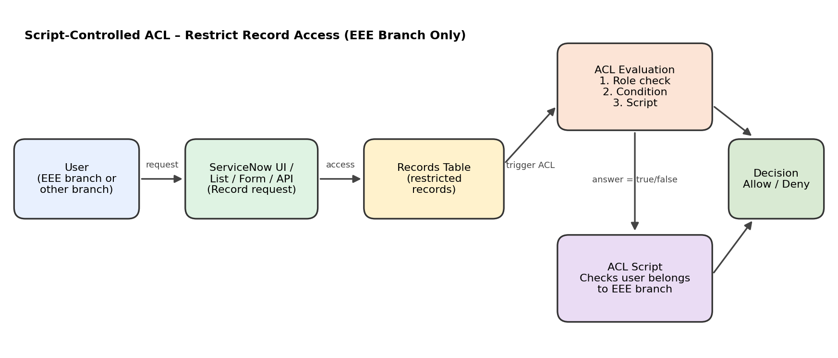
Figure 1: Architecture and data flow of the script-controlled ACL solution
Components and Flow:
- A user opens the records list or form in the ServiceNow platform.
- The platform checks the table-level ACL for the read operation.
- ACL evaluation runs in order: role check, condition, then the advanced script.
- The ACL script checks whether the logged-in user belongs to the EEE branch using gs.getUser().
- The script sets answer = true (allow) or answer = false (deny); records are hidden from users outside the EEE branch.

Sample ACL Script:
(function () {
// Allow admin users full access
if (gs.hasRole('admin')) {
return true;
}
// Allow only EEE branch users to see EEE records
if (gs.hasRole('bb1')){
return true;
}
// Deny access for all others
return false;
})();

